NAME___________________________LAB MEETING DAY/TIME________________

Lab 2: GEOLOGIC TIME - KEY

# **Exercise 1, PART 1**

**Label the sequences of events on the figures below and on next page**

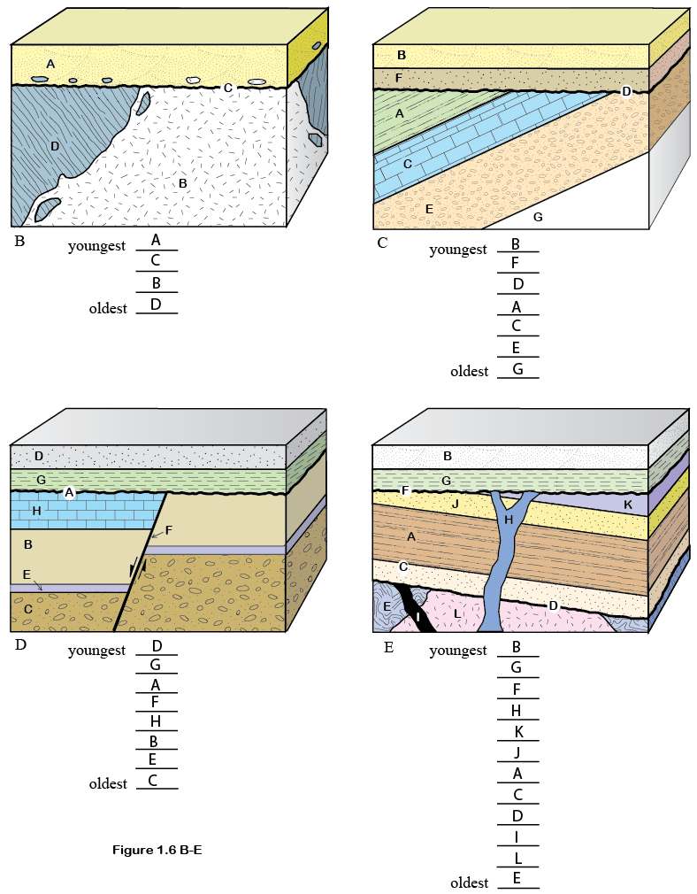

# **Exercise 1, PArt B**

**1.**

***Vishnu Schist; superposition and cross-cutting relations.***

**2.**

***Bass Limestone; superposition.***

**3.**

***Dox Formation; superposition.***

**4.**

***Tapeats Sandstone; superposition.***

**5.**

***Kaibab Limestone; superposition.***

**6.**

***Tapeats sandstone, Bright angel shale, muav limestone***

**7.**

***It changes from a nonconformity (west) to an angular unconformity (east).***

**8.**

***Ordovician and Silurian; the Devonian System is represented by the incised-valley filling Temple Butte Formation labeled on left side of the diagram***

**9.**

***Devonian deposits are rare, occurring as lenses of limestone that filled incised valleys carved into the top of the Muav Limestone.***

**10.**

***The area was covered with a warm, shallow sea in which thick accumulations of carbonate sediment were deposited.***

**11.**

***After deposition of the Redwall Limestone, there was a drop in sea level, resulting in erosion of the upper part of the Redwall. The Surprise Formation reflects deposition and filling of erosion valleys. The Supai Formation resulted from more widespread flooding by an Early Pennsylvanian seaway.***

**12.**

***The absence of Ordovician (and Silurian) strata suggests that the area was standing above sea level, resulting in nondeposition and erosion.***

**13.**

***Vishnu Schist represents deposition of sedimentary rocks that were then metamorphosed and intruded (Zoroaster Granite) during an episode of Precambrian mountain building (collisional tectonics). Prior to deposition of the Bass Limestone, the mountains were eroded to their roots, thereby exposing the Vishnu and Zoroaster rocks at the surface. This flat erosional surface was flooded by a late Precambrian seaway in which the Bass, Hakatai, Shinumo, and Dox Formations were deposited. The area was subjected to tilting and uplift, which stripped away most of the Bass–Dox strata. The area subsided and was flooded by a Cambrian ocean in which the Tapeats, Bright Angel, and Muav Formations were deposited. The ocean withdrew due to a fall in sea level or gentle uplift (or both). The area stood high and dry during Ordovician, Silurian, and most of Devonian time. During this time, shallow valleys were eroded into the top of the Muav Limestone. As sea level rose in the Late Devonian, these low valleys were filled with carbonate sediment (Temple Butte Formation). The area was flooded by a shallow ocean during the Mississippian Period, but exposed again at the end of the period, resulting in erosion of shallow valleys in the top of the Redwall Limestone. During Pennsylvanian and Permian time the area subsided and collected a thick accumulation of limestone, shale, and sandstone. Subsequent to this deposition, the Colorado River cut the deep gorge now known as the Grand Canyon.***

**14.**

***Nonconformity between the Vishnu Schist and Tapeats Sandstone. This represents creation and erosion of a major mountain range.***

# **Exercise 2 - Part C**

**1. Make a list here that puts events in order, oldest to youngest.**

***Oldest 1. Deposition of Bright Angel Shale***

***2. Deposition of Muav Limestone***

***3. Deposition of Temple Butte Formation***

***4. Deposition of Redwall Limestone***

***5. Deposition of Supai Formation***

***6. Early displacement of the Toroweap Fault***

***7. Erosion of Grand Canyon***

***8. Erosion of ancient Toroweap Valley***

***9. Basalt filling ancient Toroweap Valley***

***10. Lava dams***

***11. Basalt cascades***

***12. Most recent eruption of Vulcan’s Throne***

***Youngest 13. Late displacement of Toroweap Fault***

**2.**

***The lake behind the dam would be 1,425 ft deep.***

**3.**

***Approximately 450 to 500 ft (derived from cross-section).***

**4.**

***Approximately 2000-2300 ft (derived from cross-section).***

**5.**

***The upper basalt flows are approximately 4,100 ft above sea level, the lower Toroweap Valley basalts at 2,300 ft above sea level.***

***4,100 – 2,300 = 1,800 ft in 1.185 million years yields a rate of about 1,519 ft per million years.***

# **Go on to exercise 2 in your lab manual**

# **Exercise 2 – Conodont data**

**1. Follow the directions on page 21 to complete the figure below.**

***Diagram should be similar to below, with ranges of conodonts shown. Carboniferous-Permian Boundary should be labeled at layer 16/5***

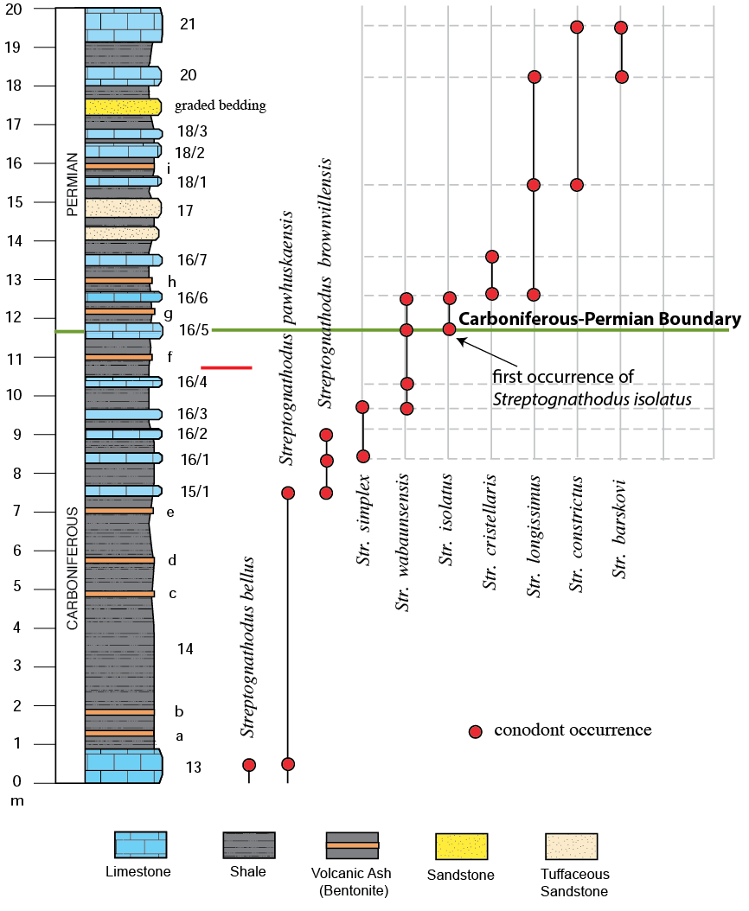

**2. Follow the directions on page 22 to complete the table below.**

***Sample averages (from table 2.2) for samples e., f., g., and i.***

***e. 0.047595 = 299.75 millions years (see graph below)***

***f. 0.04750 = 299.2 million years ago***

***g. 0.04730 = 298 million years ago***

***i.*** ***0.04718 = 297.39 million years ago***

***Bed 18/4 0.1714 = 1 billion years ago***

**3.**

***Ages from the bentonites make stratigraphic sense (i.e., the ages decrease in an upward direction). However, the zircon from bed 18/4 yields an age of 1 billion years, which does not make sense. This is a graded turbidite bed that brought material eroded from an older source region. Hence this age reflects the age of the source terrane and not the age of deposition of bed 18/4.***

**4.**

***The Carboniferous–Permian boundary is located at bed 16/5 (first occurrence of Streptognathodus isolatus). The closest bentonites to this bed are “f” and “g” with ages of 299.2 and 298 million years, respectively. Hence the age of the beginning of the Permian Period is between 299.2 and 298 million years ago***

# **Post lab reflection**

**What concepts were most difficult in today’s lab activities?**

***Any answers are okay here. If several students comment on same difficulties, perhaps discuss in next class. Also let me (Jenny) know so I can address those concepts in lecture.***

**What concepts were easiest to grasp?**

**What questions did today’s activities make you think of? What do you want to learn more about?**